Software Engineering

Student result management system

T n b k yesasvi

AP18110010199

CSE-d

SRMS CLASS DIAGRAM

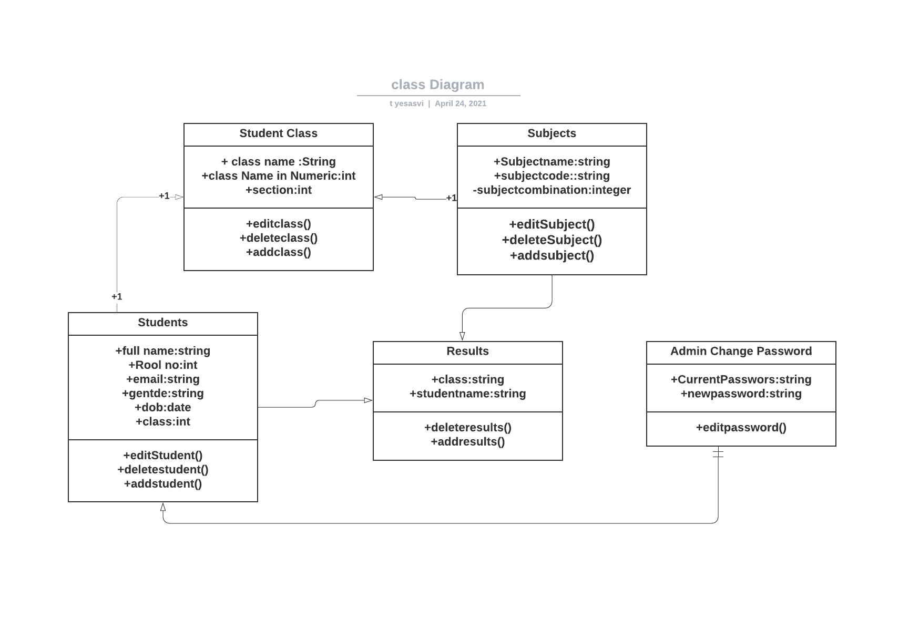SRMS Object diagram

It is based on how to new student to the existing class

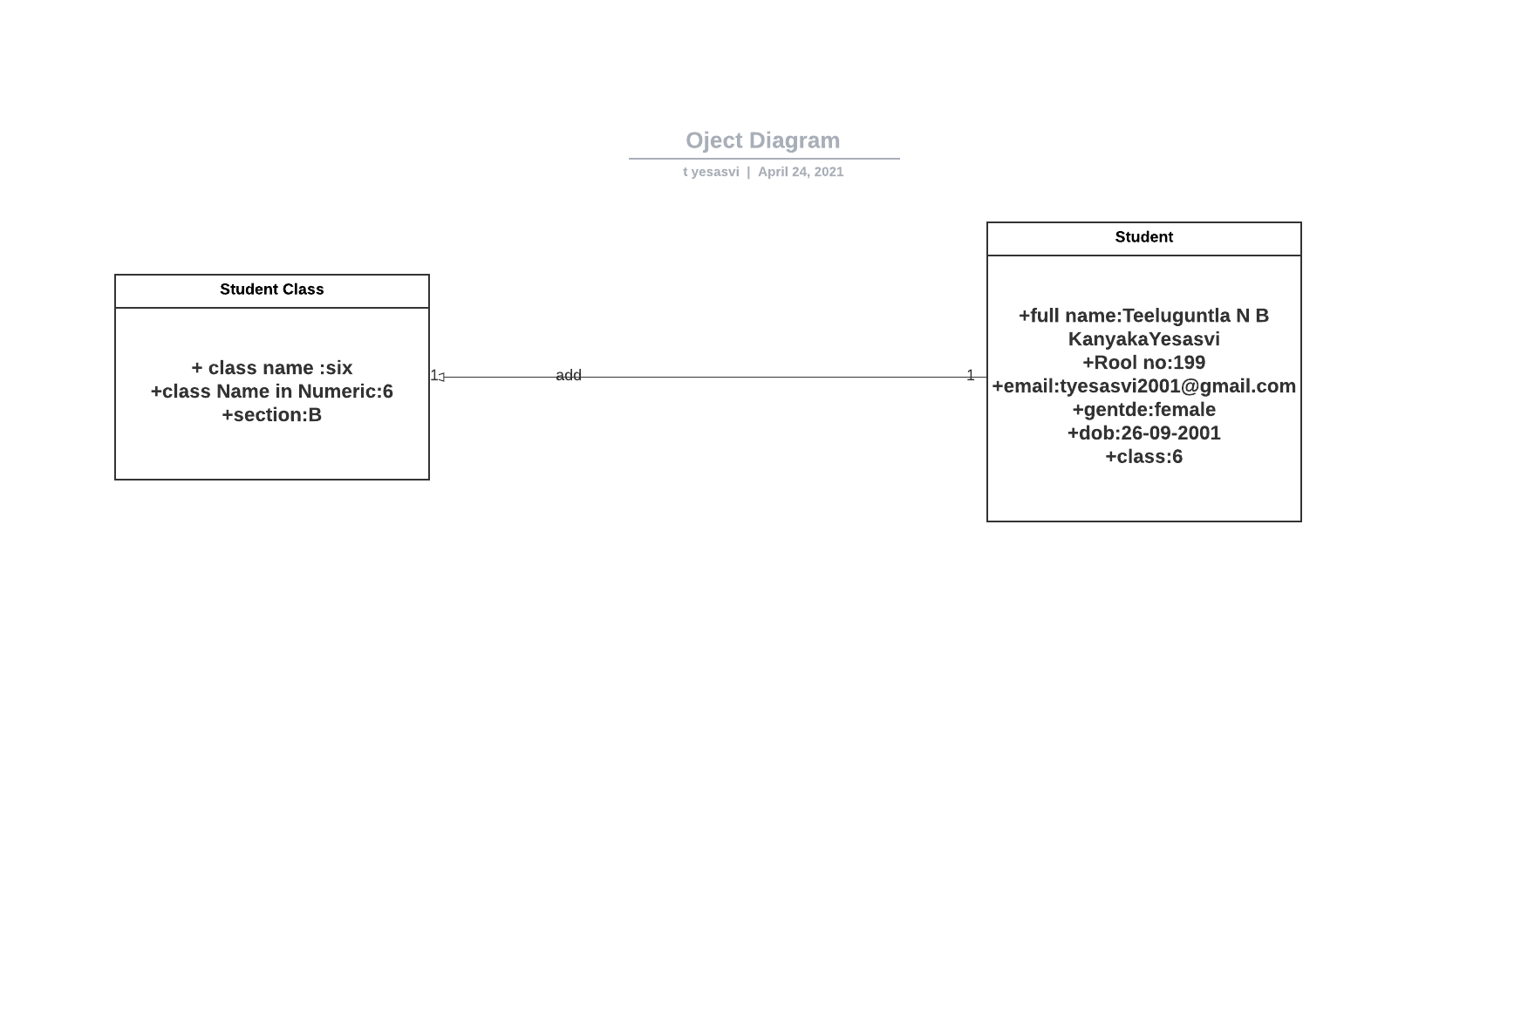

SRMS Sequence diagram:

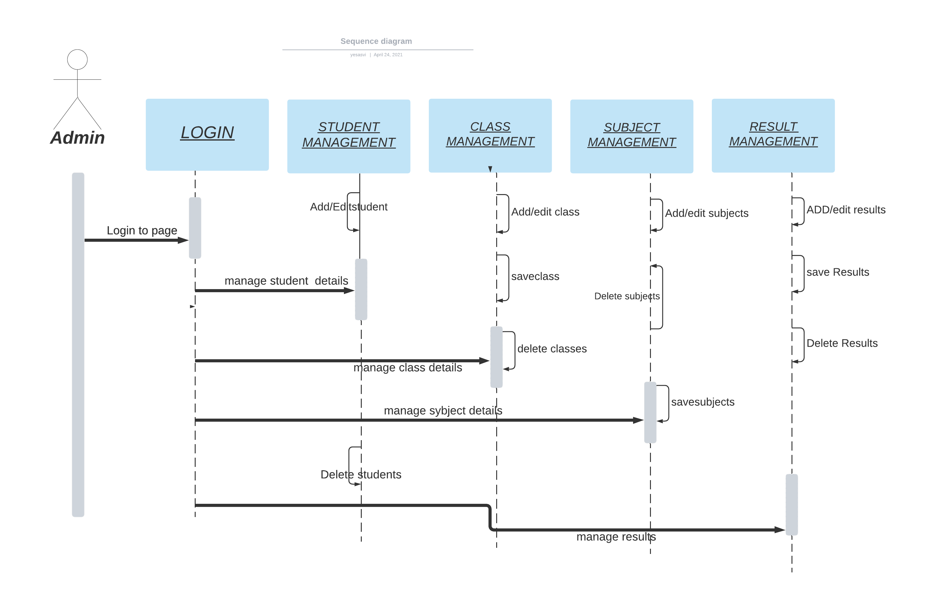

SRMS Collaboration diagram:

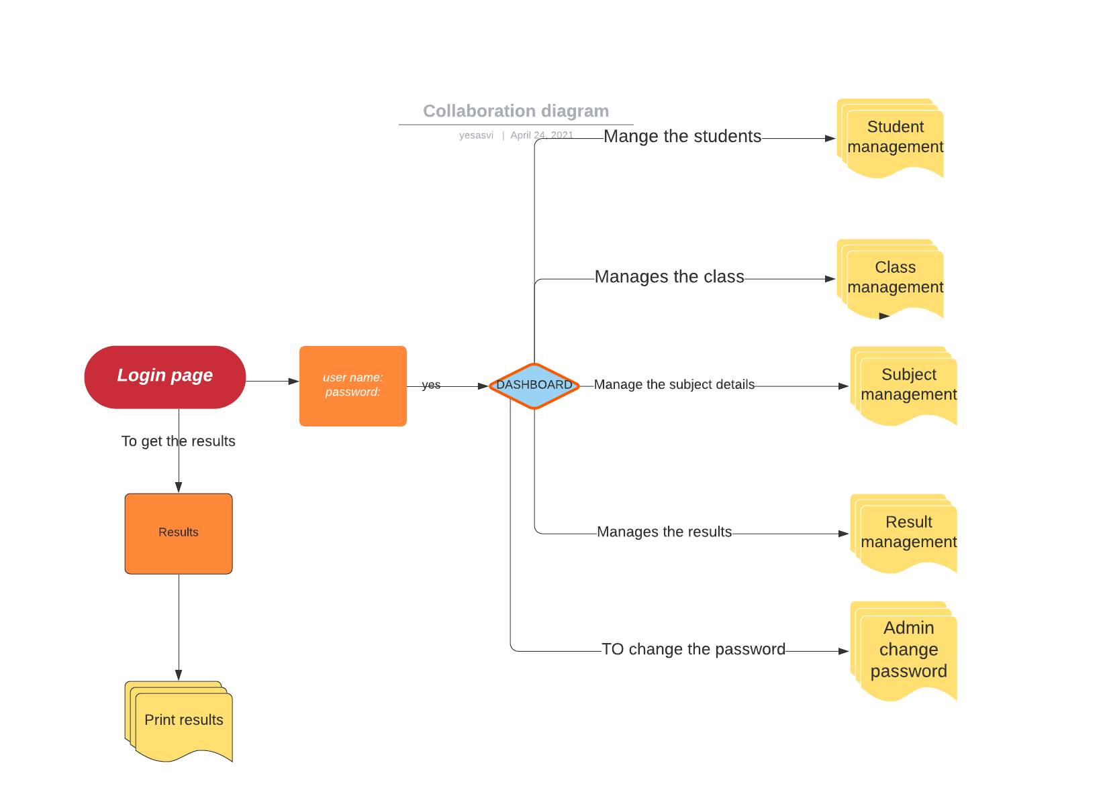

State-chart diagram

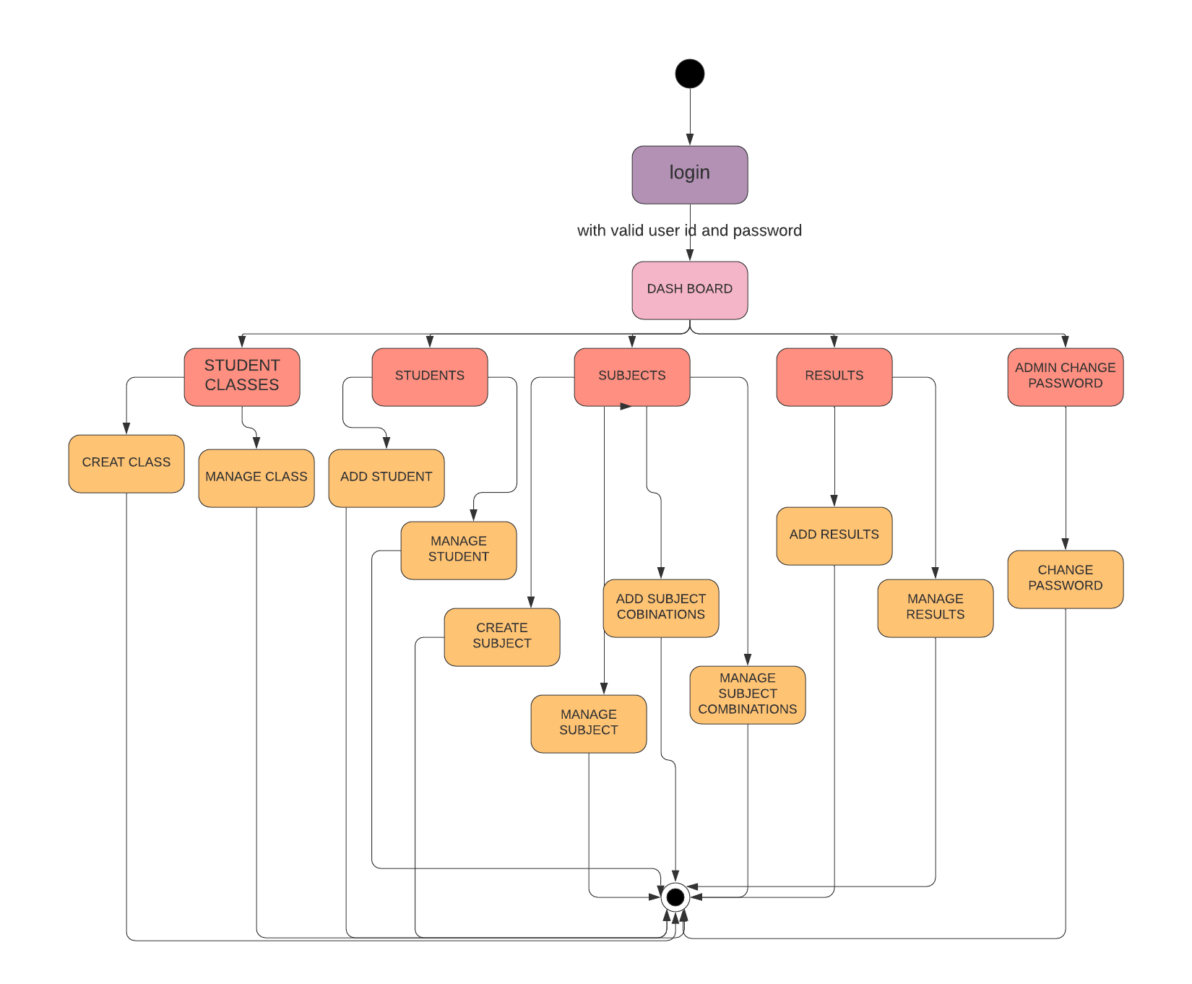

ACTIVITY DIAGRAM

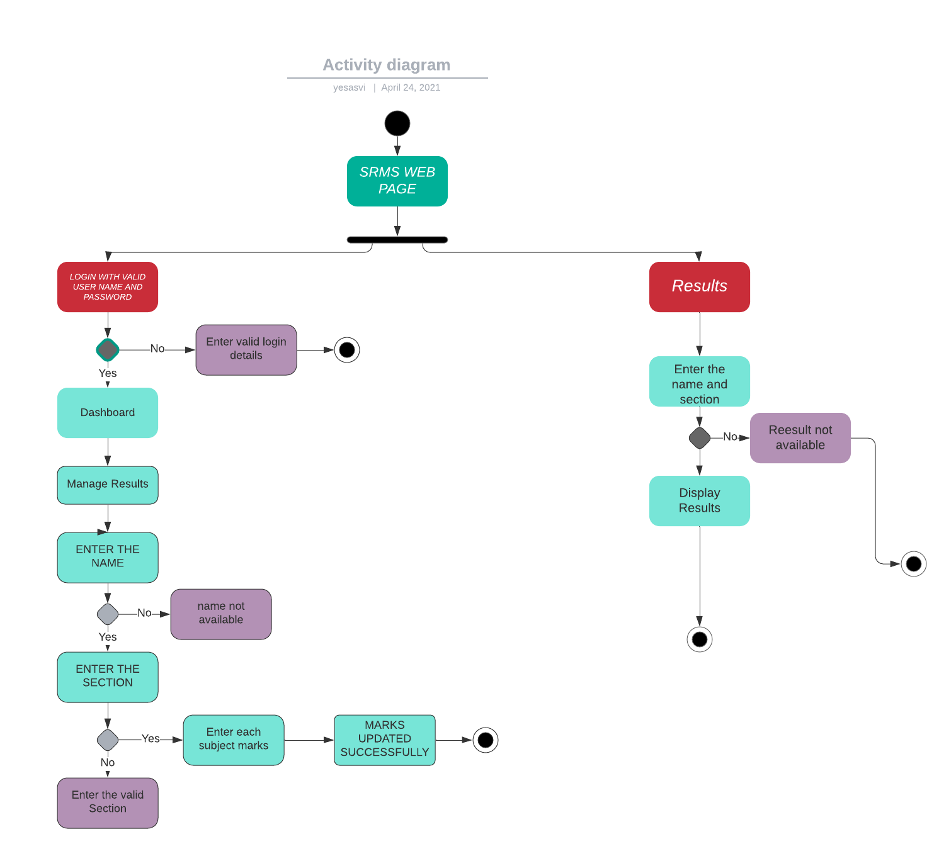

Component diagram

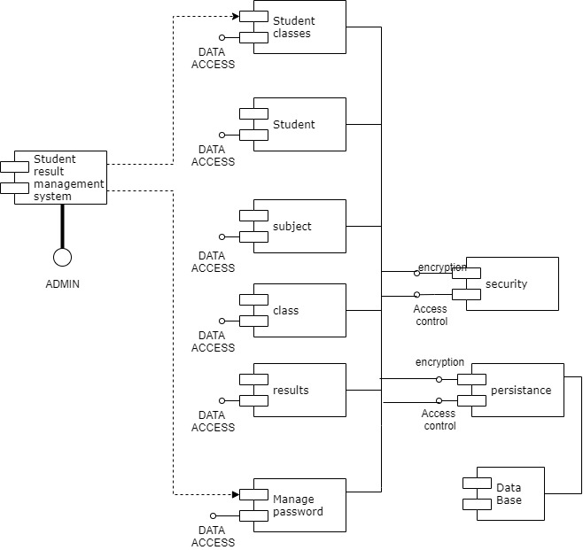

Deployment diagram

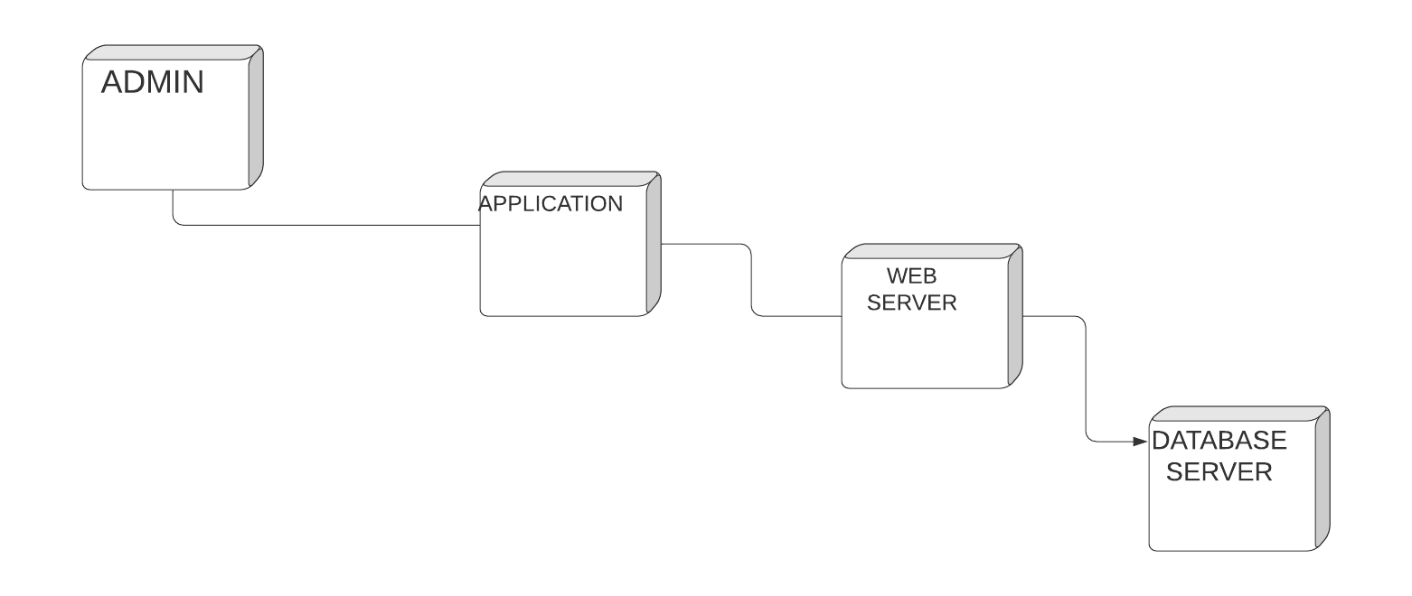

Testing:

How to enter the marks of the student and How a student can check their marks

Admin page:

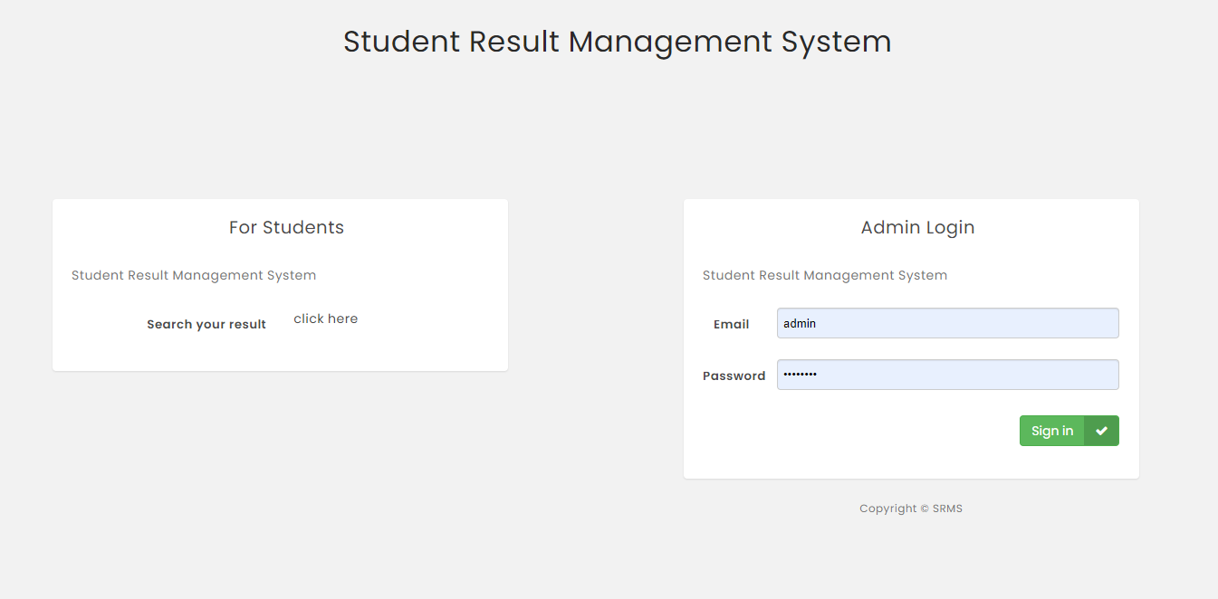

DashBoard:

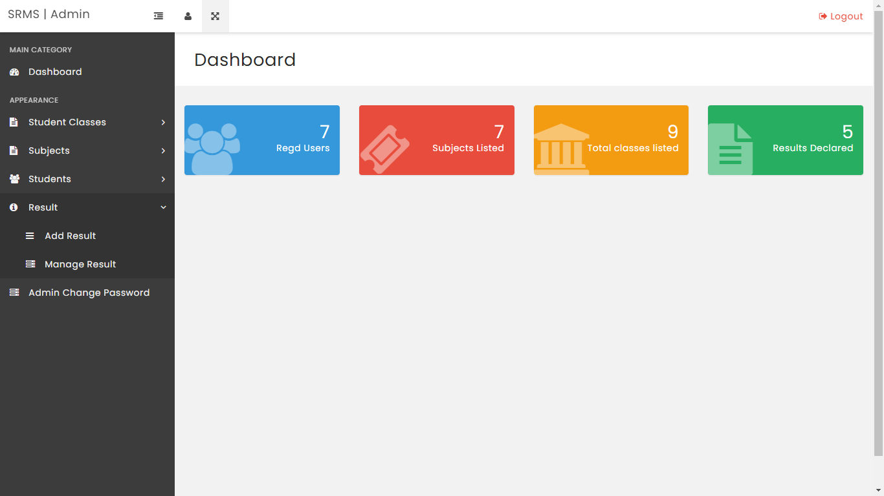

To enter the student marks: Results->Add results->marks will be updated

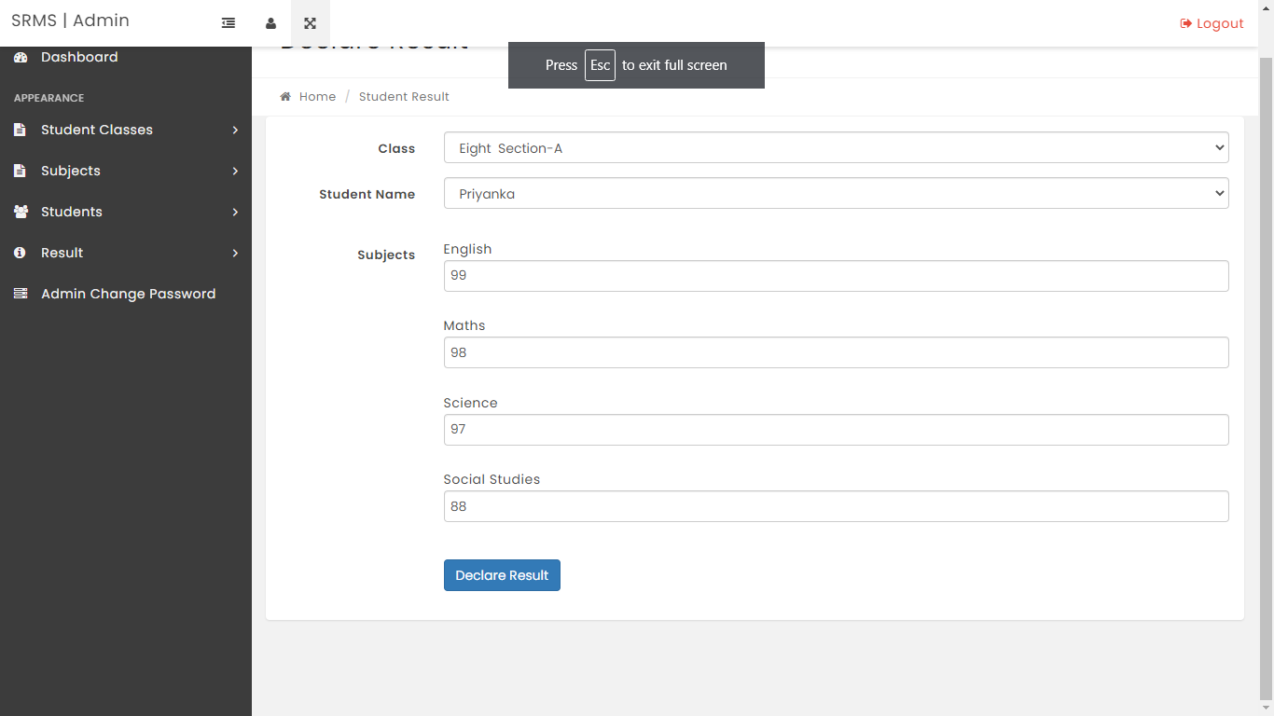

To Check the student marks by the students/guardian check on the web page



By entering the roll id and class:

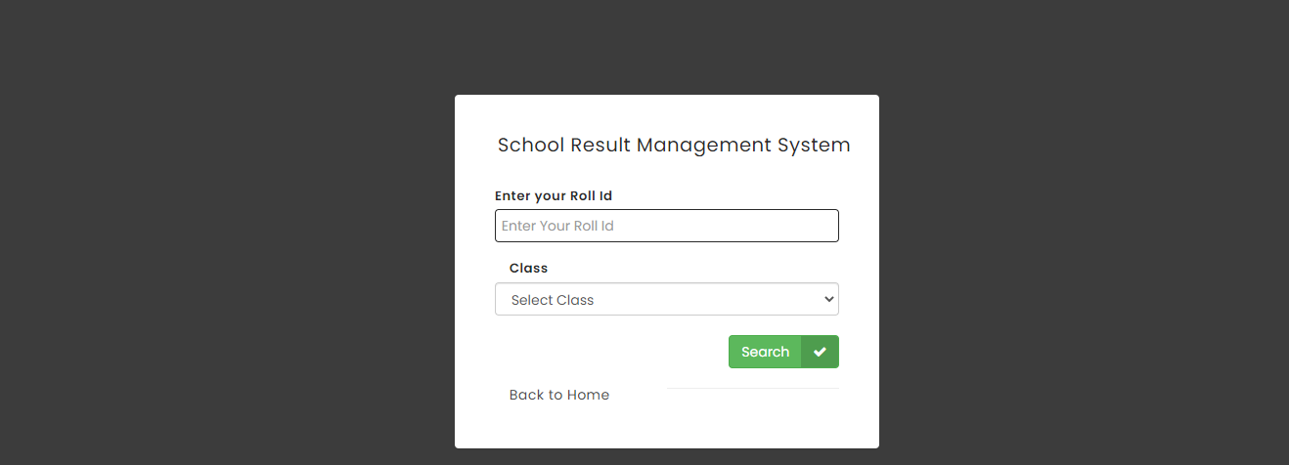

They can view their marks and take a softcopy

